MOONFUL
Written and drawn by: Mary Bernadette G. Pacres

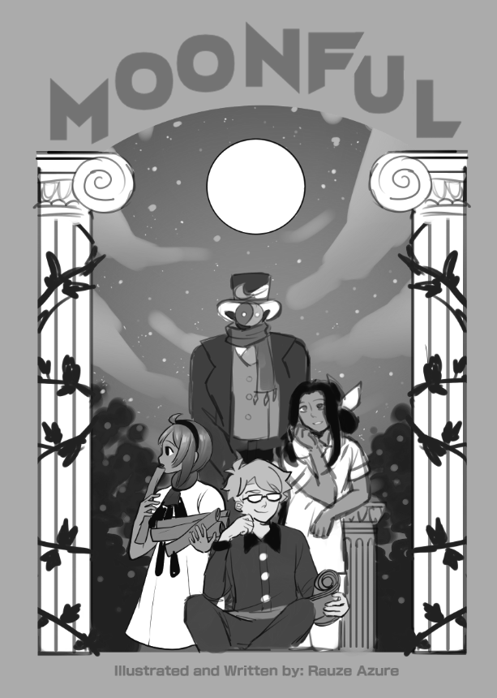

⭐summary:
3 random people share the same dream setting with a mysterious entity that asks each of them one question--their answers will determine their fate when they wake up.

🌟theme:
🍥not letting desperate situations shake your beliefs
🍥forming new knowledge when sharing it
🍥fantasy, philosophical

✨plot:
one evening, 3 random people meet up in the same dream setting. they are bewildered by the circumstance, then they noticed a mysterious entity greeting them, introducing itself, and explaining to them the rules of the special dream occasion.

the question is "what is humanity's purpose?" if the entity is pleased with their answers, they will have one wish granted when they wake up, if its dissatisfied, their greatest fear will come to reality. they are given a minute each, and as they answer, the dream environment shifts according to their explanation.

after each of them answered, they chatted a bit hoping they could possibly meet each other one day. in a snap, they awoke and noticed something different.

Page estimate: 36 - 45 , 10 pages draft⬇️
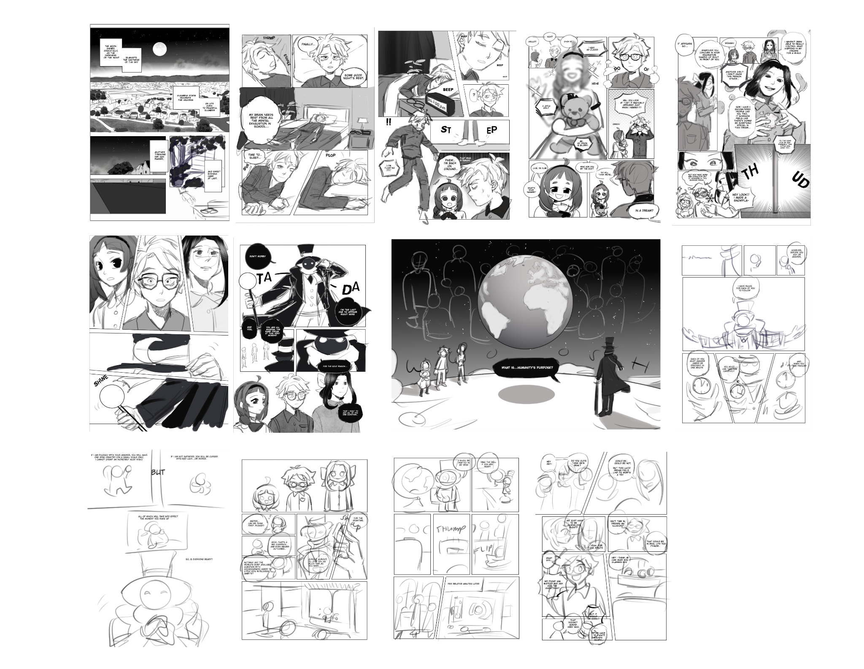
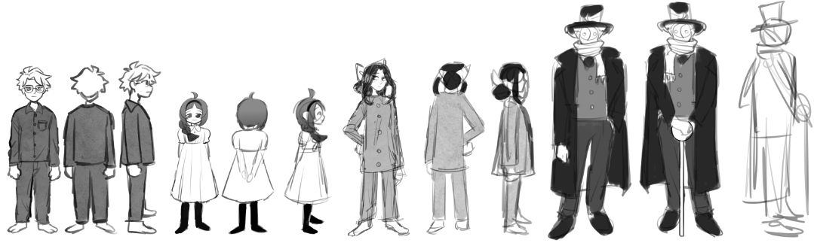
B = boy, LG = little girl , TG = teen girl , Mr = entity guy

☝️ACT 1 = (5 pages) sleeping, all 3 awoken in the same dreamscape

✌️ACT 2 = (- pages) entity appears, reason and rules introduced, they are skeptical but took time to think, they each answer in different environments

👌ACT 3 = (- pages) the kids chat, answers are calculated, each wake up to something new, mr thinks to himself, a brief lore about the entity’s will be shown (and will be about 2 pages only)

Note: refer to my notion page for character info, Page 11 and up are to be changed, stuff will be added before they answer *some of the kids show nervousness when answering

SCRIPT🖊️

[ACT 1]

P1

[town night exposition]

narration:

Dreams are stories our minds create.

dreams may have meaning or none at all.

but what if—
at the night we spend to sleep,
we dream with a goal and in the dream we’re kept enthralled—

and wake with clarity to a brighter day ahead…

or perhaps..shall a darker fate await?

P2

Boy:

(drops on bed) *exhale*

(mind) finally on bed

(chibi)

welp, time to sleep

*yawn*

*plops to sleep*

P3

clock dings to 12:00am

(slowly fades) ding ding ding ding

*slowly wakes up*

(floats in white dreamscape) *surprised*

(mind) i'm floating??!!

*touches ground*

oh- *phew* that was strange...

(little girl notices)

P4

lg: hello!

hm? oh hi

boy: (mind) a little girl? Ah..my vision is blurry..i need my glasse-

*poof* (glasses appear)

Woah! Will you look at that! It magically appeared just when I needed it!

So uhm..who are you by the way?

Do you think we’re…

P5

In a dream?

It appears so..

Whatever you conjure in your imagination shapes up right in front of you

Woah

I haven’t been able to really control what happens in my dreams for a while

Another girl? I don’t know this person either...

Nor have I encountered people like you two, it somehow feels like there’s gonna be something special in this dream..

Its the same for me and probably this little girl here too

But how many more people are gonna pop out of nowhere in this random dream…

Hey look! I made a snowfla-

*THUD* (cane hits the floor)
P6
(everyone got shocked)
(2 close-up shots of the entity)

[ACT 2]

P7
Do not worry

I am the last one to appear right here

And yes, you are all sharing the same dream at this very moment

For the sole reason that I want to ask all of you one question..

P8

What is..humanity’s purpose?

…

*boy opens mouth then it gets zippered*

However, before you ask or answer, i have rules for each of you to follow:

Each of you must answer under or precisely in ONE minute

And when you are finished, if i am pleased with your answer, you will have one wish granted (on a small scale only, i cannot grant an incredibly huge wish) ,if i am not satisfied, you will be cursed with bad luck...or worse. (tense-looking)

All of the results will be evident the moment you wake up.

mr: so, *hands clapped* Is everyone ready?

all 3: *chibi shocked faces*

lg: can we..have time to prepare, mister? please?

boy: wow..that's a big question..and bigger outcomes..

(4th wall break) tg: *sarcastic* nothing like asking the world's most arguable question to little kids in their pajamas with consequences, amirite?

mr: alright alright, i'll give you all as much time as you need. for the meantime
*clap clap*

(environment shifts to a simple victorian-esque office and mr. shifts to a chibi form)

i'll be waiting in my desk, ring the bell if you're ready
(he sits on the chair reading a book)

(the kids are given time to think, as much time as they want)
(a few relative minutes later)

(the kids gather close, whispering)

boy: hey hey- do you think he's real?

tg: could be, could be not, but this lucid dream feels like its worth a try

...

lg: we just have to be ourselves and answer what we think, right?

yeah..for 1 minute

b: isn't time in dreams an illusion?
Tg: that could be in real life too y'know...

What if WE fight him instead and ask him OUR questions?
Like what is he?
Why is he wearing fashion from the Victorian era?
Why is he interested in seeking our answers?

Maybe he’s on omniscient being but we’re in a dream so we could use any power to try and beat him

that doesn't sound very nice…

But it would be cool

Do we have to fight?

hey i think he can hear you glasses boy
and this isn’t that kind of shounen manga

its THREE against ONE!! in a dream so that means we can overpower ourselves to—

*cover his mouth* NO. doesn't seem like you're the one in-charge here. that 'thing' is.

somehow...i have a feeling he's the one that all brought us here together

if that is..you're all real right?

yes, of course i'm real. i just went to sleep and here i am.

yes *nods me too*

*deep breath*

well...let's try to think about our answers quietly now.

okay

(shots of the office)

tg: i'll go first.

*stands up and goes forward to the desk*

hello? mr. i would like to answer you first

oh wonderful!

if you're ready, hold this orb, then close your eyes and think of a place you would like to go

oh? alright then

*holds orb and close eyes*

magic smoke engulfs the two and disappears

(a small screen appears in front of lg and boy)

Mr and tg are on top of a building, as she answers, panels show shots of different angles in the city and people’s lives

tg's answer is more about freedom, happiness, people helping each other and living the moment, concept of entropy

lg's answer: God-centered, love, bible verse/s

boy's answer: combination of the previous two, philosophy, aristotle and socrates

after they all answer, they go back to the whitespace or office room

Each one of us has a different purpose in life

We have free will which makes us free to choose anything, believe anything, --

But..what kinds of things? Things that exist in this world

Spending time with your family, friends,

So as long as in the end, you lived a good life

Not only making yourself happy but sharing that happiness with others

Humanity’s purpose is to live and enjoy the life they’re given

All sorts of things happen, and a lot of things remain uncertain..

We’ve only got one life..so for me, it's better to live in the moment.

That’s all

(pause)

*insert complimentary word*

Mr opens a screen and tells lg to prepare
(A few seconds later)

(tg gets teleported back to chair in the office with boy and is switched with lg)

Lg teleports outside of a church with mr

I believe that humanity’s purpose is to honor God..

[“Do all in the glory of God” -1 Corinthians 10:31]

and that can be done through fellowship and living out the way of the Lord.

Since we are created in His image, our purpose is fulfilled if we live a life devoted to HIm.

To live in God’s way is to follow his commandments, read the Bible, and displaying a Christ-centered character; selfless, loving, forgiving, patient, humble, kind, generous, and more

In this world..it's not very easy to do

And it's hard for me too... but i will keep on trying to be someone God wants me to be

Because even if it sounds difficult in this life, I know I and everyone can do it if they try, and to never give up no matter how difficult it gets. Because Jesus went through so much pain and even died for us, his love is the ultimate love which we could all learn from.

*insert complimentary word*

(lg gets poofs back to her chair)

Boy, it's your turn

(boy teleports to ancient greek building with entity)

…

So uhm

should i really answer this?

*bonks* indubitably

(boy rubs head and thinks)

First... i wanna say that i agree with what the girls have just answered, it's good for humans to seek happiness but they don’t have to stop there-

Which is why there is wisdom that religion offers.

Both of these concepts could go hand in hand as religion offers contentment, fortunately not only temporary but long-term..long lasting happiness
Truly, each individual has a unique purpose, but for humanity as a whole, it's through living a good life, exhibiting equality among all kinds of people, and serving humanity for its betterment and advancement.

Each person can contribute for the greater good as any person is capable of reason and language. After all, aristotle says that man is a rational animal. Not only humans but everything in this world has a function (ergon) paired with its virtue (arete)

Ultimately, I believe that everyone should engage in reason, open themselves to curiosity & understanding..

If all does this, humanity’s purpose to strive becomes attainable more than ever.

To put it simply, humanity’s purpose is to (use their brains) think, ask, reason, and talk to each other until they all figure it out.

*ding*
*insert complimentary word*

They all are in whitespace and confetti drops

[ACT 3]

mr says that their answers will be evaluated within 3 minutes, they can chat for a moment then wake up to the results

they talked about their views on each answer, wondered if they could meet again, they all hugged then woke up

boy woke up to a huge menacing wolf-like creature but when he said his pet's name it became friendly. b was happy

lg has wings and turns invisible everytime she uses it

tg can bring her paintings to life and can use it as portals (big canvases)

mr is fascinated by them, and thought that those kids are different, special in their own way. He reveals that he won't be the one to give them the consequence but they themselves will if they do not know how to use their head clearly and know themselves better because it largely affects their future.

Thank you, dear children

I will now be assessing your [answers] within 3 minutes, after that you will all wake up and see your results

While waiting, feel free to hang around here for a moment

Toodles

*disappears*

(this is awkward)

Well i guess that’s the end of that

So how are you guys?

Nervous but okay

A bit overwhelmed

This has been one weird dream..

We still don’t know about that thing

Say..do you think we’ll all meet again?

maybe..

You guys seem cool

still not sure if you’re real though..

(tg holds b & lg’s hands)

Seems and feels real enough

(tg places her arms around their shoulders)

Hey this dream may be weird but it was pretty fun, don’t you think?

I never had a dream like this..and i think we could be friends

(b smiles and gives them a group hug)

GROUP HUG

Wait--

Hey we’re about to fal--

(b wakes up)

A huge dark wolf-like creature is glaring above him

B is surprised

But the creature became friendly and familiar

[insert dog name]?

The creature wags its tail and barks

It sits on the floor and b gets up from his bed

B hugs his dog

[not much dialogue from the two girls]

As the panels show the two, the entity is narrating

The boy has his pet dog turn into a larger stronger creature which could help protect anyone from danger and could reverse back to its original form.

The little girl has wings but turns invisible everytime she uses it, she uses it to explore and help people in secret

The teen girl paints in a huge canvas and goes to a nature-filled environment

The shot pans to the sun and slowly transitions to a moon, then to the eyes of the entity and he turns back to see the three children

Out of the previous people I've asked questions from, these children are different...I felt their conviction as they shared their beliefs, and I sensed there was good in their hearts..
So, they all have a wish granted,

The bad luck was just a bluff, I am not that evil to curse them with ill fortune, only they will lead themselves to their demise....if they do not have a sense of self..or a bigger outlook in life.

-END-

